555 California Street, California and Kearny. A 52 storey building

Bank of America, San Francisco CA Dec 2007 – March 2010
System Analyst
Project Summary:
The project involved reengineering and enhancing the portfolio management system after BoA and Merrill Lynch merger making it important to provide access to integrated marketing information for examining and modeling any aspect of a prospective transaction for immediate execution. The project also gives detailed information for a particular account, such as Daily Report, Monthly Report and Yearly report.
Responsibilities:
- Created BRD, FSD, Use Case Diagrams, Activity Diagrams, Sequence Diagrams and ER Diagrams in MS Visio.
- Facilitated and managed meeting sessions with various stake holders, CSR agents, CSR managers, development and QA team to gather business and marketing requirements based on the Agile methodology.
- Managed market analysis by providing measured guidance and positioning resulting in increased positive assessments of the project.
- Conducted stand up meetings daily and was assigned the role of a SCRUM master and worked on the burn-down chart
- Worked with Sales and Marketing in identifying their needs and wants in order to come up with the most effective business plan. Supported marketing/sales with research and market sizing.
- Executed trend reports, season over season performance comparisons and other database analytics to optimize catalog and e-commerce direct marketing campaigns.
- Track and forecast marketing campaign for the new product on board.
- Developed, analyzed and assisted in implementing marketing database and reporting tools.
- Implemented project selection, delivery, forecasting and business processes to implement the wealth management tool utilizing combination of waterfall and agile methodologies
- Produced a variety of routine and ad-hoc financial reports, packages and pro forms for senior management using advanced MS Excel functions
- Utilized Structured Query Language (SQL) queries in for Data Analysis and Data Modeling.
- Derived effective marketing strategies through customer-centric segmentation and identification of target markets.
- Performed requirement analysis for the portfolio management application and developed financial plan for the SMA accounts.
- Analyzing massive and highly complex data sets, performing ad-hoc analysis and data manipulation.
- Created complex database queries, procedures, functions and triggers for data manipulation.
- Created dashboards, metrics and goals using Business Objects

Not there before!

Add on to the existing online banking! Make it available to online banking infrastructure. So, customers can tap into the vast knowledge base of Merrill Lynch’s investment managers.

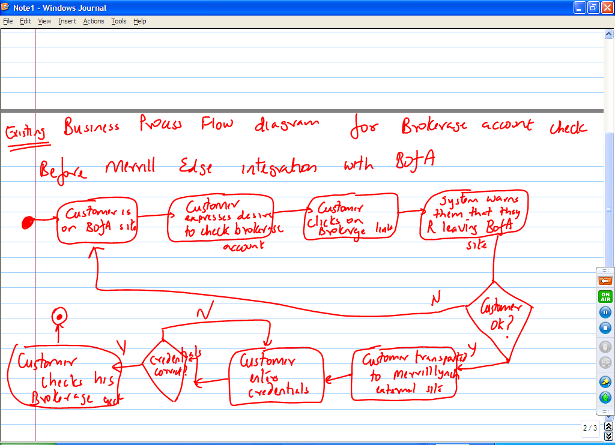

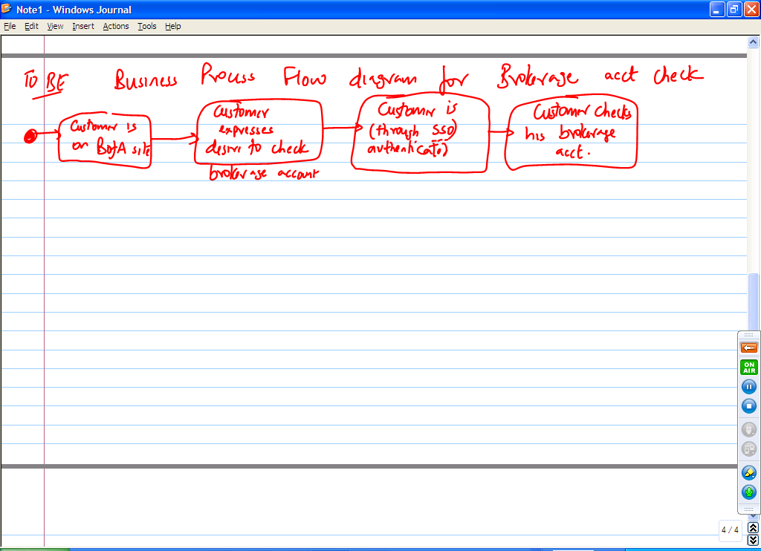
Tell me the difference between business requirements and functional requirements

Biz requirements are high level statements of business needs and wants. Functional Requirements are further fleshing out of the business needs and wants through Use Cases. E.g., for my MerrillEdge project, the business requirements will be:
- Customers should be seamlessly integrated between our 2 lines of business
  - Customers should be able to check their checking, savings (came from BofA side of integration) and brokerage accounts (came from Merrilly Lynch side of Integration) without having to identify themselves to the system again
- System should have time out security built in so as to avoid security threats
- Customers should have 24X7 access to their customer requirement
- Customers should be able to trade securities
- Customers should have the option to transfer funds between their regular DDA accounts and brokerage accounts

Use cases (Functional requirements) will be
- Login to the site
- Sell securities (directly derived from BR 4)
- Buy securities (directly derived from BR 4)
- Transfer funds

